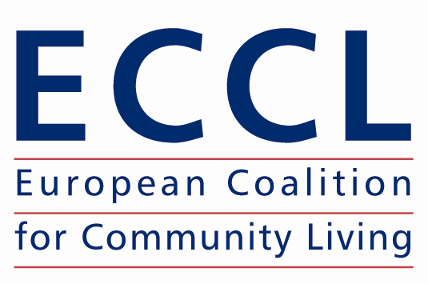


Funding exclusion while promoting inclusion?
- The use of the European Union funding to maintain the institutionalisation of people with disabilities -

Seminar of the European Coalition for Community Living
24 March 2010 – Brussels
Thon Hotel Brussels City Centre

The European Union has allocated substantial resources for projects that will improve the lives of European citizens. These funds, known as Structural Funds, have the potential to make a significant positive impact on the situation of people with disabilities by facilitating the development of community-based services as alternatives to institutional care. Yet, in some Member States, Structural Funds are being used to renovate existing, or build new, long-stay residential institutions. This practice perpetuates the marginalisation and social exclusion of disabled people. It is also in direct contravention of human rights standards and EU policies on promoting social inclusion.

On 24 March, the European Coalition for Community Living (ECCL) is organising a one day seminar on the use of Structural Funds. The seminar will highlight ECCL’s concerns about the use of Structural Funds to maintain the system of institutional care and consider recommendations for reform. A particular focus of the discussions will be how Structural Funds can be better used to promote alternative services that would enable disabled people to live and participate in the community as equal citizens.

The highlight of the Seminar will be the launch of ECCL’s report on the use of Structural Funds, with findings from Romania and Hungary. The seminar will give participants the opportunity to consider ECCL’s report and discuss key questions, such as:

- What are the human rights implications of using Structural Funds to maintain institutional care?
- What are the main barriers to the development of community-based services?
- How can Structural Funds be used to promote the development of community-based services for people with disabilities as alternatives to institutions?
- What role can civil society play in this process?

The seminar is organised in cooperation with the Open Society Institute Brussels and with the financial support of the Open Society Mental Health Initiative. ECCL’s project on the use of Structural Funds was implemented in cooperation with the Institute for Public Policy, Romania and the Soteria Foundation, Hungary.

Draft Programme

9:00 – 10:00 Registration

10:00 – 13:00 Plenary session I
Chair: Jim Mansell, Tizard Centre, University of Kent

- Welcome and introduction (ECCL and the Open Society Institute Brussels)

- Opening words by representatives of the European Commission and the European Parliament (TBC)

- Setting up the context: the situation of people with disabilities in institutional care (Judith Klein, Open Society Mental Health Initiative)

- Launch and presentation of ECCL’s report on the use of Structural Funds for the renovation of existing or the building of new institutions for people with disabilities (John Evans, ECCL/European Network on Independent Living and Camilla Parker, consultant ECCL)

- Presentation of key findings from Romania and Hungary (Elena Iorga, Institute for Public Policy Romania and István Sziklai, Soteria Foundation Hungary)

- Discussion (with participation of the national authorities)

13:00 – 14:00 Lunch

14:00 – 17:00 Plenary session II
Chair: Representative of the European Disability Forum (TBC)

- Overview of the legal and policy context: disability and non-discrimination law and policies in the European Union (Mark Priestly, University of Leeds, TBC)

- Response to ECCL’s report findings by representatives of the European Commission (Representatives of DG Regional Policy and DG Employment, Social Affairs and Equal Opportunities, TBC)

- How can the European Union support the transition from institutional to community-based care for people with disabilities? (Jan Pfeiffer, Chair of the Ad Hoc Expert Group on the Transition from Institutional to Community-based Care/Children’s High Level Group)

- The role of civil society in the monitoring of Structural Funds: presentation of good practice (Javier Güemes, Fundación ONCE)

- Panel discussion with the speakers

- Seminar conclusions (Gerard Quinn, Centre for Disability Law and Policy, National University of Ireland, Galway)

Important information

- The working language of the seminar is English.

- Please note that this programme is subject to changes. The updated programme will be published on the ECCL website www.community-living.info.

- The seminar will take place at Thon Hotel Brussels City Centre, Avenue du Boulevard 17, B-1210 Brussels, Belgium.

- There is no participation fee, but registration is compulsory. To register for the seminar, please complete the Registration Form. The deadline for registration is 5 March 2010.

Contact details

European Coalition for Community Living (ECCL)
c/o NCIL
Canterbury Court, Unit 3.40
1 – 3 Brixton Road
London SW9 6DE
United Kingdom

Tel: + 44 20 7587 3982
E-mail: coordinator@community-living.info

The European Coalition for Community Living (ECCL) is a Europe-wide cross-disability initiative working towards the social inclusion of people with disabilities by promoting the provision of comprehensive, quality community-based services as an alternative to institutionalisation. ECCL’s vision is of a society in which people with disabilities live as equal citizens, with full respect for their human rights. They must have real choices regarding where and with whom they live, choices in their daily lives and real opportunities to be independent and to actively participate in their communities. To this end ECCL carries out advocacy activities to promote community living and de-institutionalisation at the European level, disseminates examples of good practice in the provision of quality community-based services and monitors developments around Europe. Since the beginning of 2008, ECCL has been based at the European Network on Independent Living (ENIL).

